|  |
| --- |
| 3M Corporate R&D |
| Enterprise Team Foundation Server –System Architecture |
| SEMS Lab |

|  |
| --- |
| Mike O'Brien  12-1-2014 |

# Contents

1 Contents 1

2 Table of Figures 3

3 Abstract 4

4 Summary 4

5 ETFS Infrastructure 4

5.1 Environments 4

5.2 Scalability 5

5.3 Hardware 5

6 Subsystems Configuration 7

6.1 TFS 7

6.2 SharePoint 7

6.2.1 Requirements 7

6.2.2 More SharePoint Products tasks for Team Foundation Server 8

6.3 SQL Server 8

6.3.1 Database Service Required 9

6.3.2 Trial/Demo 9

6.3.3 DEV 9

6.3.4 QA 10

6.3.5 Prod 10

7 Process 11

7.1 Microsoft Visual Studio Scrum 2013.4 Process Template 11

7.1.1 Work Item Tracking 11

7.1.2 Plan and track work using work item types 11

7.1.3 Queries 12

7.1.4 Areas and Iterations 12

7.1.5 Reports (http://msdn.microsoft.com/en-us/library/dd380714.aspx) 13

7.2 Customizations 17

7.2.1 Completed & Original Estimate 17

7.2.2 PBI Type 17

8 ETFS System Specification 17

8.1 Team Project Collection Strategy 17

8.2 Team Project Strategy 18

8.3 Security 18

8.3.1 TFS Administrators 18

8.3.2 Team Project Collection 18

8.3.3 Team Project 19

8.4 ETFS Website Homepage 20

8.4.1 Allow a user to request a new Team Project 20

8.4.2 Display current monetization for owned Team Projects. 20

8.4.3 Display users of currently owned Team Projects. 20

8.4.4 Schedule Training with the Solutions team. 20

8.4.5 Current status of all running Services (dashboard) 20

8.4.6 Audit trail of Service changes and modifications. 20

8.4.7 Report Portal to available reports for owned Team Projects. 20

8.4.8 Read service policies: 20

8.5 Reports 20

8.6 Customized Process Template 20

8.7 Build Services 20

8.7.1 Enterprise Build Machines 20

8.7.2 Build Services Dependencies 20

8.7.3 Build Services – Software Configuration Management (SCM) 21

8.7.4 Continuous Deployment 21

8.8 Monetization 21

8.9 External to 3M Availability 21

9 Support 21

9.1 Requirements 21

9.2 Support Team Structure 21

10 Solutions 22

10.1 On Boarding 22

10.1.1 Existing TFS Systems 22

10.1.2 Non-TFS Existing Systems 22

10.1.3 Level of Service 23

10.1.4 Upgrade Path – SOP for Upgrades 23

11 Service Level Agreement (SLA) 23

11.1 Uptime 23

11.2 Support 23

11.3 System Maintenance Service Windows 24

11.4 Security Patches 24

11.5 Team Foundation Server Upgrades 24

# Table of Figures

Figure 1 - Development Environment Architecture 0

Figure 2 - QA Environment Architecture 1

# Abstract

SEMS operates an Application Lifecycle Management service to business groups within 3M in the form of the Enterprise Team Foundation Server (ETFS). ETFS aids business groups by consolidating current development environments, training teams on best usage of the system, and offering guidance on usage of tools. This document outlines the ETFS system from a system architecture perspective, and provides the technical specification that allows for installation, operation and usage of the service by 3M business groups.

# Summary

The specifications outlined in this document are­­ for the 3M Enterprise Team Foundation Server (ETFS). High level requirements are outlined in the ‘ETFS – High Level Requirements’ documentation, which also includes a high level project description with background information.

There are sub-systems that make up ETFS in addition to the core Team Foundation Server functionality, as shown below.

The System Architecture is presented in the form of configuration of the Core TFS Functionality to support the ETFS, and the definition and level of customization allowed from within the subsystems

# ETFS Infrastructure

## Environments

The ETFS Service is made up of multiple environments. Below is a list of environments with the role that environment is filling.

## Scalability

The ETFS Service is considered a Scale-Out Team Foundation Server deployment. That is, multiple Application Servers make up the front service, and can be expanded to accommodate more users. A Scale-Out deployment was selected to serve the potential 3000 users of the system.

From the TFS Planning Guide v1.3 in Table 7, a dual virtualized front end scale-out deployment will scale to 3000+ users. The below are minimum recommendations from the TFS Planning Guide – Capacity Planning spreadsheet.

|  |  |  |  |
| --- | --- | --- | --- |
| Deployment Option | Example Specification | Metrics  (rps = requests per sec.) | Virtualized Hardware Max Users |
| Scale-out Servers | 1-2 x AT: 1 dual Processor, 4G RAM, 500G Disk  1 x DT: 2 Quad Processors, 23G RAM, 2TB Disk | Max Current Active TPC: 75  Est. rps total: 79 – 675  Est. rps on AT Server: 79-338 | 4200 |

For production use, the ETFS machine specification are 2 Application Tier (AT) virtual machines with a physical hardware database cluster for the Data Tier (DT). These specifications exceed the recommended specification, and give room for growth to an estimated 4200 users. If the 4200 user level is exceeded, or performance degradation is observed, another Application Tier machine will be deployed to expand capacity.

## Hardware

The ETFS Service consists of 3 main environments – Development, QA, and Production. Each of these main environments is outlined below in system component diagrams. The role of each environment is below in the Hardware Role table.

|  |  |
| --- | --- |
| Environment | Role |
| Development (DEV) | * development of new ETFS solutions * prototyping of new functionality * trial of 3rd party tools |
| Quality Assurance (QA) | * Staging and testing of deployments * Any change to the PROD environment is first deployed and tested in QA. |
| Production (PROD) | * Hosting of ETFS Instance for use by 3M clients |

Each of the Application Tier machines are Virtual Machines running in the 3M data centers. The data tier machines (database cluster) are physical hardware, as per the 3M IT Database team recommendation.

Figure 1 - Development Environment Architecture

The role of the Development environment is to provide a location for new system enhancement development or trials. Examples would include a new service portal, a service integration with a TFS API Service, or a trial of 3rd party software.

Figure 2 - QA and Prod Environments Architecture

For all environments:

Application Tier machines:

* IIS Logging – configure to log to D drive
* TFS Cache – configure to use D drive

# Subsystems Configuration

ETFS is made up of 3 primary systems – TFS, SharePoint, and SQL Server. The subsystem configuration is detailed in the following subsystem sections.

## TFS

* Creation of DefaultCollection

## SharePoint

Published SharePoint requirements for Team Foundation Server 2013 are documented here:

<http://msdn.microsoft.com/en-us/library/hh667648.aspx>

Following are the SharePoint requirements for the Enterprise Team Foundation Server (ETFS) service.

### Requirements

|  |  |
| --- | --- |
| SharePoint Version | SharePoint Foundation 2013 with SP1 |
| Authentication | NTLM is the recommended authentication provider.  Team Foundation Server Extensions for SharePoint Products does not support Basic authentication or anonymous authentication.   |  | | --- | | TipTip | | In SharePoint Server 2013, Microsoft deprecated Windows classic-authentication in favor of claims-based authentication. TFS supports both, but for claims-based authentication, the authentication provider must be NTLM. TFS will only support NTLM-based claims. | |
| Dashboard Requirements | Two dashboards that are based on SQL Server Reporting Services are shown |
| Install SharePoint Products for TFS | [How to: Set up remote SharePoint Products for Team Foundation Server](http://msdn.microsoft.com/en-us/library/hh548140.aspx)  You can use Team Foundation Server extensions for SharePoint Products configuration wizard to install SharePoint Foundation 2013 on a different server from Team Foundation Server. |
| Service Account | You must add the service account for Team Foundation Server to the Farm Administrators group on the SharePoint products site. |

### [More SharePoint Products tasks for Team Foundation Server](javascript:void(0))

[Manually Install SharePoint products for Team Foundation Server](http://msdn.microsoft.com/en-us/library/dd578615.aspx)

Install and configure SharePoint Server 2013 for use with Team Foundation Server. Although the procedures in this topic are tailored to SharePoint Server 2013, you could use them to install any of the supported SharePoint products. It’s all very similar.

[Add the service account for Team Foundation Server to the Farm Administrators group](http://msdn.microsoft.com/en-us/library/dd631884.aspx)

You must add the service account for Team Foundation Server to the Farm Administrators group on the SharePoint products site. Team Foundation Server configures this for you automatically if you install SharePoint Products on the same server as Team Foundation Server.

[Configure the enterprise application definition for Team Foundation Server](http://msdn.microsoft.com/en-us/library/ee126232.aspx)

Final configuration is required in the Team Foundation Server extensions for SharePoint Products only if you’re using an enterprise edition of SharePoint Server.

[Verify SharePoint products for Team Foundation Server](http://msdn.microsoft.com/en-us/library/dd578601.aspx)

Steps you can use to verify that an existing installation of SharePoint Products is ready to work with Team Foundation Server.

## SQL Server

Published database requirements for Team Foundation Server 2013 are documented here: <http://msdn.microsoft.com/en-us/library/dd631889.aspx>.

There are 5 environments that make up the ETFS service – Trial/Demo, DEV, QA, and PROD. Each is listed below with the ETFS requirements.

### Database Service Required

Database Services required for each environment include:

• Database Engine Services Instance

• Full-Text and Semantic Extractions for Search

• Analysis Services Instance

• Reporting Services Instance

### Trial/Demo

The Trial/Demo environment is made up of disposable virtual machines used for team trials and demo for hands-on labs, and presentations. They are single server installs with SQL Standard 2012 SP1, and leverage the built-in SharePoint 2013 Foundation install. A single service account is needed for SharePoint integration and Reporting Services.

### DEV

The DEV instance is a shared instance of MS SQL Server 2012 SP1 with a cumulative patch (KB2793634) from <http://www.microsoft.com/en-us/download/details.aspx?id=36215> . This brings the version to 11.0.3128

Database Services, Analysis Services, and Reporting services are used by Team Foundation Server 2013.

|  |  |  |
| --- | --- | --- |
| Property | Description |  |
| Database Instance | DEVSQL46 |  |
| Analysis Services Instance | DEVSQL46 |  |
| Reporting Services Instance | Installed on Application Tier – database hosted on DEVSQL46 |  |
| Supported edition | MS SQL Server 2012 SP2 |  |
|  |  |  |
| Collation settings | Database Engine | SQL_Latin1_General_CP1_CI_AS |
| Analysis Services | Latin1_General_CI_AS |
| Authentication | Windows authentication |  |
| Permission | Database Services – sysadmin access | US-SEMS-ETFS-Admin |
| Analysis Services – Admin Access | US-SEMS-ETFS-Admin |
| Reporting Services – Admin Access | US-SEMS-ETFS-Admin |
| Service account | Database Services: | USAC\usfetfsdevs |
| Analysis Services: – | USAC\usfetfsdevr |
| Reporting Services - Used by common data sources to connect to Tfs_Warehouse (relational warehouse) and Tfs_Analysis (cube) | USAC\usfetfsdevr |

### QA

|  |  |  |
| --- | --- | --- |
| Property | Description |  |
| Database Instance | PRODSQLCL219 |  |
| Analysis Services Instance | QASQL06 |  |
| Reporting Services Instance | QASQL06 |  |
| Supported edition | MS SQL Server 2012 SP2 |  |
|  |  |  |
| Collation settings | Database Engine | SQL_Latin1_General_CP1_CI_AS |
| Analysis Services | Latin1_General_CI_AS |
| Authentication | Windows authentication |  |
| Permission | Database Services – sysadmin access | US-SEMS-ETFS-Admin |
| Analysis Services – Admin Access | US-SEMS-ETFS-Admin |
| Reporting Services – Admin Access | US-SEMS-ETFS-Admin |
| Service account | Database Services: | USAC\usfetfsqas |
| Analysis Services: – | USAC\usfetfsqar |
| Reporting Services - Used by common data sources to connect to Tfs_Warehouse (relational warehouse) and Tfs_Analysis (cube) | USAC\usfetfsqar |

### Prod

|  |  |  |
| --- | --- | --- |
| Property | Description |  |
| Database Instance | PRODSQLCL220 |  |
| Analysis Services Instance | PRODSQLRS09 |  |
| Reporting Services Instance | PRODSQLRS09 |  |
| Supported edition | MS SQL Server 2012 SP2 |  |
|  |  |  |
| Collation settings | Database Engine | SQL_Latin1_General_CP1_CI_AS |
| Analysis Services | Latin1_General_CI_AS |
| Authentication | Windows authentication |  |
| Permission | Database Services – sysadmin access | US-SEMS-ETFS-Admin |
| Analysis Services – Admin Access | US-SEMS-ETFS-Admin |
| Reporting Services – Admin Access | US-SEMS-ETFS-Admin |
| Service account | Database Services: | USAC\usfetfsprods |
| Analysis Services: – | USAC\usfetfsprodr |
| Reporting Services - Used by common data sources to connect to Tfs_Warehouse (relational warehouse) and Tfs_Analysis (cube) | USAC\usfetfsprodr |

### Archive

|  |  |  |
| --- | --- | --- |
| Property | Description |  |
| Database Instance | tfsarchive.usac.mmm.com |  |
| Analysis Services Instance | tfsarchive.usac.mmm.com |  |
| Reporting Services Instance | tfsarchive.usac.mmm.com |  |
| Supported edition | MS SQL Server 2012 SP2 |  |
|  |  |  |
| Collation settings | Database Engine | SQL_Latin1_General_CP1_CI_AS |
| Analysis Services | Latin1_General_CI_AS |
| Authentication | Windows authentication |  |
| Permission | Database Services – sysadmin access | US-SEMS-ETFS-Admin |
| Analysis Services – Admin Access | US-SEMS-ETFS-Admin |
| Reporting Services – Admin Access | US-SEMS-ETFS-Admin |
| Service account | Database Services: | USAC\usfetfsprods |
| Analysis Services: – | USAC\usfetfsprodr |
| Reporting Services - Used by common data sources to connect to Tfs_Warehouse (relational warehouse) and Tfs_Analysis (cube) | USAC\usfetfsprodr |

Database requirements for Team Foundation Server 2013:

<http://msdn.microsoft.com/en-us/library/dd631889.aspx>

Database Server – dual machine SQL Cluster

* Installation, configuration, and maintenance performed by 3M IT Database Services

# Process

The software development process can be well supported by ETFS in the form of a Process Template. The TFS Process Template ‘Microsoft Visual Studio Scrum 2013.4’ will be customized, and redeployed into the ETFS infrastructure as the ‘**ETFS - Microsoft Visual Studio Scrum 2013.4’ Process Template. Leveraging the existing template will allow for ease of upgrades to newer version of TFS.**

## **Microsoft Visual Studio Scrum 2013.2 Process Template**

The process guidance provided by TFS for the Microsoft Visual Studio Scrum 2013.2 process template is available at <http://msdn.microsoft.com/en-us/library/ff731587.aspx>. The online process guidance contains the below diagram to show the work item types (WITs), reports and dashboard available.

### Work Item Tracking

Work Items Types

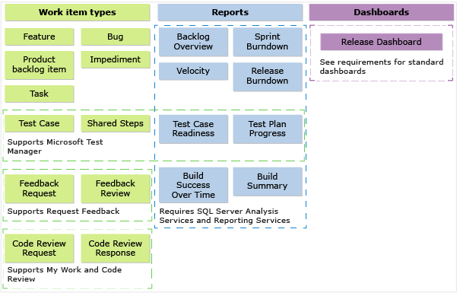

### Plan and track work using work item types

Teams plan their project by capturing features and requirements as product backlog items (PBIs). They track bugs, work, and blocking issues using the bug, task, and impediment WITs. Features support a first level of portfolio management to view a rollup of PBIs across teams.

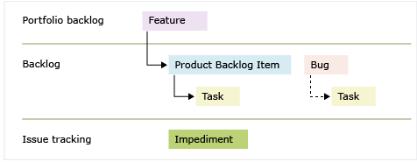

### Queries

When a new Team Project is created, the below default shared queries are created.

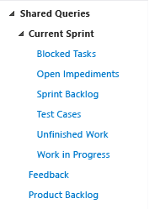

This process guidance will be updated with any customizations and hosted on the ETFS main website.

### Areas and Iterations

No default Areas will be created when a new Team Project is created.

The default Iteration structure below weill be created. This can be modifed by the team project administrator(s).

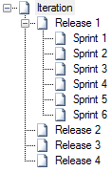

### Reports (<http://msdn.microsoft.com/en-us/library/dd380714.aspx>)

* Project Management Reports
  + Backlog Overview - <http://msdn.microsoft.com/en-us/library/dn641200.aspx>

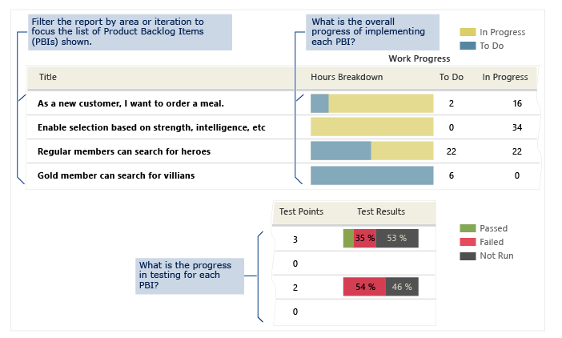

* + Release Burndown - <http://msdn.microsoft.com/en-us/library/ff731579.aspx>

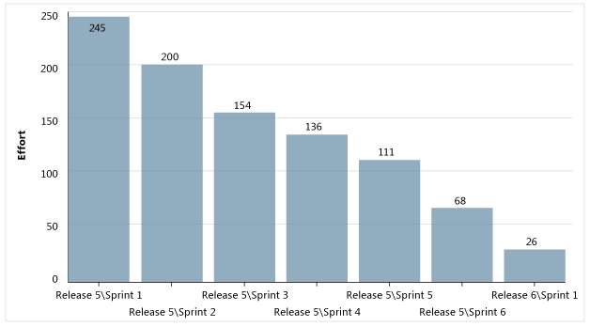

* + Sprint Burndown – <http://msdn.microsoft.com/en-us/library/ff731588.aspx>

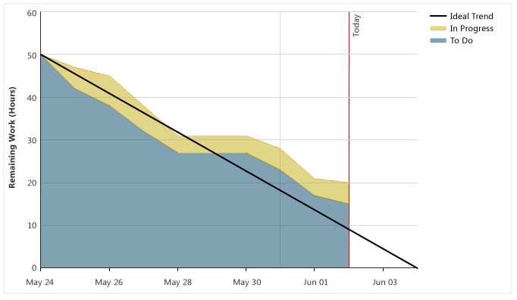

* + Velocity – <http://msdn.microsoft.com/en-us/library/ff731575.aspx>

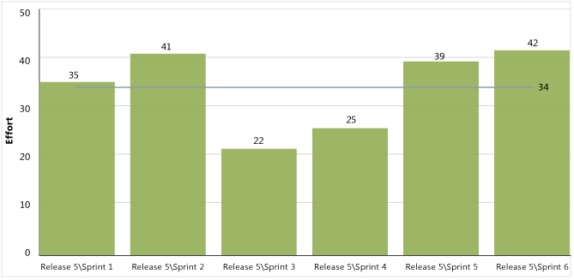

* Build Reports
  + Build Success Over Time – <http://msdn.microsoft.com/en-us/library/dd380643.aspx>

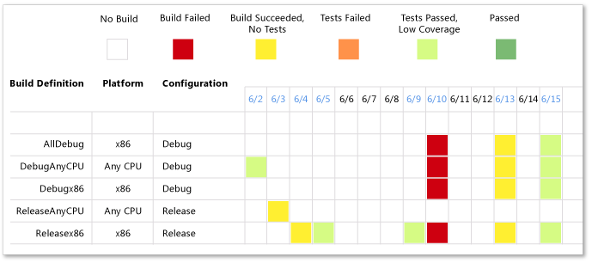

* + Build Summary – <http://msdn.microsoft.com/en-us/library/dd380708.aspx>

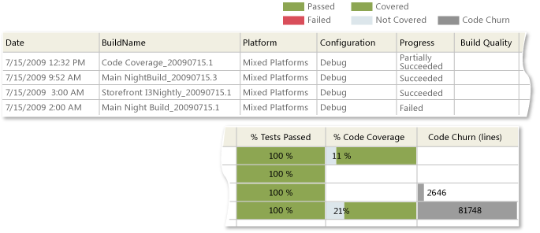

* Test and bug reports
  + Test Case Readiness – <http://msdn.microsoft.com/en-us/library/dd380713.aspx>

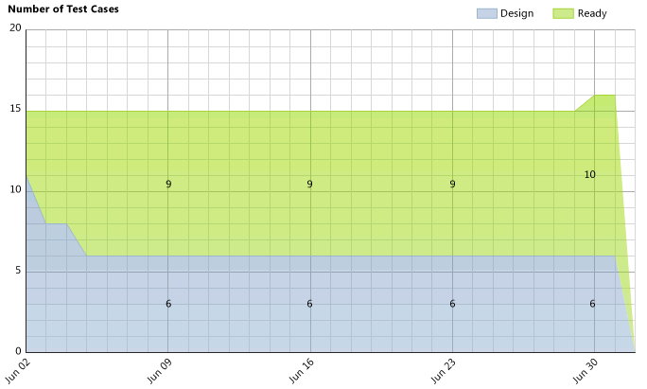

* + Test Plan Progress – <http://msdn.microsoft.com/en-us/library/dd380702.aspx>

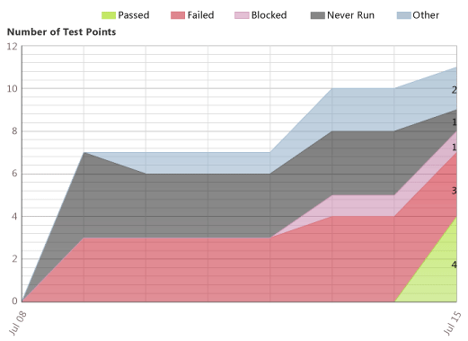

## Customizations

Customizations made to the base template detailed in the following sections.

It is also important to note – customizations to Team Projects that involve the process will be handled through a support request to the ETFS support team. This is to ensure the change is made in accordance with the Process Governance, and the team project is not put into a non-functional state.

### Completed & Original Estimate

The Scrum template only has ‘Remaining Work’ on a Task as this is the only metric that Scrum requires. However there are many teams that gain value through other metrics and the Scrum Guide does not say anything about not using them. I often add these two fields to the Scrum template for teams.

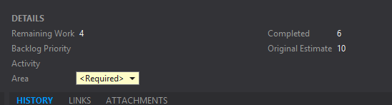

### PBI Type

Often organizations like to differentiate between Functional, Technical, or Regulatory PBI’s and this is another field to add. Making sure of course that it becomes a dimension in the Cube.

* Functional
* Non-functional
* Regulatory

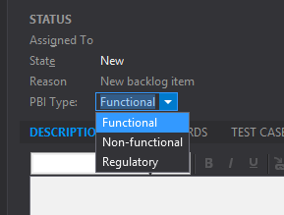

# ETFS System Specification

## Team Project Collection Strategy

As per the requirements, the Team Project Collection Strategy is ultimately to have as few Team Projects and Team Project Collections as possible.

## Team Project Strategy

## Security

A hierarchy of permissions exist within every Team Foundation Server, as shown below.

### TFS Administrators

The TFS Administrators group have full access to all services on the TFS servers. The permissions are managed from the TFS Console on the TFS Application Tier, and are not available to users without administrative permissions on the TFS servers. Within TFS, the TFS Administrators access level cannot be modified.

|  |  |  |  |  |  |  |  |  |
| --- | --- | --- | --- | --- | --- | --- | --- | --- |
|  | Administer Warehouse | Create team project collection | Delete team project collection | Edit instance-level information | Make requests on behalf of others | Trigger Events | Use full Web-Access features | View instance-level information |
| SharePoint Web Application Services |  |  |  |  | X |  |  | X |
| Team Foundation Administrators | X | X | X | X |  | X | X | X |
| Team Foundation Service Accounts | X | X | X | X | X | X | X | X |
| Team Foundation Valid Users |  |  |  |  |  |  | X | X |

### Team Project Collection

Managed in the Team Web Access interface by a TFS Administrator.

|  |  |  |  |  |  |  |  |
| --- | --- | --- | --- | --- | --- | --- | --- |
|  | Project Collection Administrators | Project Collection Build Administrators | Project Collection Build Service Accounts | Project Collection Proxy Service Accounts | Project Collection Service Accounts | Project Collection Test Service Accounts | Project Collection Valid Users |
| Administer build resource permissions | X | X | X |  |  |  |  |
| Administer Project Server Integration | X |  |  |  |  |  |  |
| Administer shelved changes | X |  | X |  | X |  |  |
| Administer workspaces | X |  |  |  | X |  |  |
| Alter trace settings | X |  |  |  |  |  |  |
| Create a workspace | X |  |  |  | X |  | X |
| Create new projects | X |  |  |  |  |  |  |
| Delete team project | X |  |  |  |  |  |  |
| Edit collection–level information | X |  |  |  | X |  |  |
| Make requests on behalf of others |  | X |  |  | X |  |  |
| Manage build resources | X | X | X |  |  |  |  |
| Manage process template | X |  |  |  |  |  |  |
| Manage test controllers | X |  |  |  |  | X |  |
| Trigger Events | X |  |  |  | X |  |  |
| Use build resources | X |  | X |  |  |  |  |
| View build resources | X | X | X |  |  |  |  |
| View collection-level information | X | X | X | X | X | X |  |
| View system synchronization information | X |  |  |  | X |  |  |

### Team Project

|  |  |  |  |  |  |  |  |  |
| --- | --- | --- | --- | --- | --- | --- | --- | --- |
|  | Create test runs | Delete team project | Delete test runs | Edit project-level information | Manage test configurations | Manage test environments | View project-level information | View test runs |
| Project Administrator | X | X | X | X | X | X | X | X |
| Build Administrators | X |  | X |  | X | X | X | X |
| Contributors | X |  | X |  | X | X | X | X |
| Project Valid Users |  |  |  |  |  |  |  |  |
| Readers |  |  |  |  |  |  | X | X |
| Team Group(s) |  |  |  |  |  |  | X |  |

Team Web Access

There are 3 Access Levels within Team Web Access. A full description of these Access Levels is on the MSDN Developer Network at <http://msdn.microsoft.com/en-us/library/jj159364.aspx>.

These are show below, with the accompanying level of functionality.

|  |  |
| --- | --- |
| Access Level | Description |
| Limited | You can give anyone limited access. There’s no license required. Limited access is helpful when you want to use TFS to collaborate with your customers or stakeholders (or anyone who’s not on your team, really). |
| Stand access (default) | Any user with a TFS client-access license (CAL) can have standard access. |
| Full | Full access is available to users who have one of these MSDN subscriptions: Visual Studio Ultimate with MSDN, Visual Studio Premium with MSDN, or Visual Studio Test Professional with MSDN. |

## ETFS Website Homepage

A self-service website will be hosted on the main ETFS website – <http://tfs.mmm.com:80/>. This website will provide the following functionality:

### Allow a user to request a new Team Project

### Display current monetization for owned Team Projects.

### Display users of currently owned Team Projects.

### Schedule Training with the Solutions team.

### Current status of all running Services (dashboard)

### Audit trail of Service changes and modifications.

### Report Portal to available reports for owned Team Projects.

### Read service policies:

* Available Services
* Process Template customization policy – see Customizing Process Templates.
* Build Services Available – including Build retention
* Symbol Server availability and retention policy

## Reports

TBD – need to determine what reports are useful for project oversight.

## Customized Process Template

Users of the ETFS system need to make a request to the ETFS Solutions team for a process template customization within a Team Project. Custom modifications of the Team Project template are implemented and deployed by the Solutions team – as long as they do not conflict with the Process Customization Governance. See Section 7.1 for a list of supported Process Templates.

## Build Services

### Enterprise Build Machines

The ETFS service supports an out-of-the-box build service. These build machines are to be equivalent to the Team Foundation Service build service, in that, they support the latest 2 versions of .Net and Visual Studio. Needs beyond this base service need to be addressed with a dedicated build machine for the Team Project.

For implementation, a single Build Controller will be available, with tags used to target specific build machines, as shown below.



The build tag “java” will be used to denote a build for the java build machine – tfsbuild03.usac.mmm.com.

The build controller will be hosted on tfsbuild01.usac.mmm.com.

Build services will be hosted under a service account reserved for the build machines, and will be added to the Team Foundation Server Service Accounts permission group.

#### Windows Build Machines

The list below details the list of software to be installed on each build machine.

| Name | Description | Done |
| --- | --- | --- |
| Operating System | Windows Server 2012 R2 | ⃣ |
| Team Foundation Server 2013 | Run the setup wizard and configure as a build machine. | ⃣ |
| .Net 4.0 | For backwards compatibility, install the previous version of .Net. | ⃣ |

#### Java Build Machine

| Name | Description | Done |
| --- | --- | --- |
| Operating System | Windows Server 2012 R2 | ⃣ |
| Team Foundation Server 2013 | Run the setup wizard and configure as a build machine. | ⃣ |
| Java | Java 7 & 8? | ⃣ |
| TFS Build extensions | Download the latest version and install to allow Team Foundation Build to execute Ant and Maven tasks. | ⃣ |
| Ant | Build tool | ⃣ |
| Maven | Build tool | ⃣ |

### Build Services Dependencies

In the event a Team Project requires the use of a 3rd party libraries outside the standard offering, a dedicated build machine for the Team Project will be needed. This requires the Team Project team to acquire hardware capable of running the desired Operating System for the Build Service.

### Build Services – Software Configuration Management (SCM)

Controlling the infrastructure in a fine grain method should allow a build machine to be constructed and if necessary – re-constructed to reproduce quality builds with re-producible accuracy.

Potential paths to implementation include:

* Snapshot of Virtual Machine
* Capture of system requirements using a detailed infrastructure scanning tool (TBD)
* Control of Build Machine software installations via an infrastructure mechanism – potentially Puppet Labs, Chef, or System Center.

### Continuous Deployment

In accordance with Continuous builds, support for continuous deployments is a future service offering for ETFS. No solution or recommendation is currently available.

## Monetization

Users of the system need to be tracked for accounting purposes.

System utilization needs to be tracked for accounting purposes.

## External to 3M Availability

External / Outsourced software development needs accessibility to a 3M Software Development System.

The externally available system can handle outsourced companies without Active Directory domain accounts.

# Support

## Requirements

A TFS version upgrade can be performed within a defined service window.

A TFS release update can be installed within a defined service windows.

## Support Team Structure

ETFS has a support team to handle support requests, maintain the system, and on-board teams.

The Service Managers:

* actively meet with new and existing teams
* maintain a relationship with these teams
* main point of contact for current teams, meaning, they raise awareness of team roadblocks

The primary roles of the *Operations* Team are:

* Handling support issues
* Keeping the system running optimally
* Performing upgrades

The *Solutions* Team performs:

* the on-boarding of new teams
* system improvements
* process customizations that fit within the supported Process Governance
* comprehensive training of teams on the best practices of the ETFS system

# Solutions

## On Boarding

Onboard team with a defined process that gives a high level of adoption of TFS.

If required, migrate source control into TFS will as high of fidelity as possible (full history)

If required, migrate Work Items into TFS with as high of fidelity as possible (full history).

### Existing TFS Systems

Teams that have an existing TFS server need a path to migrate existing project development assets to the ETFS platform.

### Non-TFS Existing Systems

### Level of Service

#### SOP for Maintenance

A Standard Operating Procedure (SOP) for System Maintenance.

IIS Log Files

Disk Space

CPU Load

OS Patching

Database Patches/updates

Load Balancer – config?

#### SOP for Support

#### SOP for Backups

#### SOP for Disaster Recovery

#### SOP for Data Retention / Team Project Artifact Archival

### Upgrade Path – SOP for Upgrades

High Level Process for the Upgrade to a new version of TFS

Of note, the Upgrade to a new version of TFS will only be performed after extensive testing in an isolated environment. Additionally, a roll back path must be contained within the upgrade plan.

# Service Level Agreement (SLA)

This is a Service Level Agreement for Enterprise Team Foundation Server services. Note: the outlined items below will be effective after the launch of the ETFS Service.

## Uptime

Predicted up time for the service will be 99.9% or better.

## Support

Support will be provided for the system from the IT Support hotline (651) 733-1000 and website (<http://ithelp.mmm.com>). Support will be provided during business hours across the continental US: 8:00 am EST – 5:00 pm PST. Support for non-business hours will be provided if a 3 day prior notice is received and approved by the ETFS Support Team.

## System Maintenance Service Windows

Necessary maintenance will be performed during scheduled service windows. Announcements for service windows will be sent 30 days in advance, and posted on the ETFS home page. System Maintenance Windows are approved by the ETFS Steering Committee prior to scheduling.

## Security Patches

Operating System and Software Security patches need to be applied to comply with 3M Security Policies. Patches and necessary system reboots will be performed without service interruption.

## Team Foundation Server Upgrades

As new versions of Team Foundation Server are released, they will go through a trial period that will test for a successful upgrade of the service to a fully operational service. Installation of new versions will be done within System Maintenance Windows – if approved – or within 2 annual Service Windows. The 2 Service Windows are: 4th full week in June, and the last week in December